

SUBJECT | English: Paper 1 |  | DATE | November 2015
GRADE | 11 |  | MARKS | 90
EXAMINERS | Mrs Leeburn,  Mrs Oosthuysen,  Mr De Reuck |  | MODERATOR | Mrs Nichas,
NAME |  |  | DURATION | 2 ½ hrs + 10 mins reading
CLASS
LOW ORDER | 61% | HIGH ORDER |  | 39%

INSTRUCTIONS
- This exam consists of 12 pages.
- Draw a right hand margin on each page you use.
- Start every new question at the top of a new page.
- Number in the middle of the page, according to the question paper.
- Leave a line between each answer.
- It is in your own interest to write legibly and to present your work neatly.

Question | 1 | 2 | 3 | 4 | 5 | Total
Possible Marks | 30 | 10 | 20 | 20 | 10 | 90
Actual Marks

COMMENT:

QUESTION 1: COMPREHENSION 30 MARKS

Read TEXT 1 and then answer the questions which follow:

1.1 What is Johnny’s (Par 1) profession? (1)
1.2 Explain why the preparation and cooking of the ortolan is described by the author as a ‘dark culinary art’. (2)
1.3 How is the idea of this delicacy being a ‘dark culinary art’ emphasized by the writer’s diction in paragraph 4? (3)
1.4 What reasons are given for the consumers of this delicacy to drape a napkin over their heads while they eat? (2)
1.5 Explain the effectiveness of the juxtaposition between the two images created in paragraph 7: the metaphor of the Ku Klux Klan and the simile involving children. (4)
1.6 Where does the reference to ‘#Blessed’ come from? (1)
1.7 Describe how the author views humanity in paragraph 10. Explain why he has this view. (3)
1.8 Why does the author consider himself a hypocrite? (2)
1.9 How does paragraph 10 relate to the image (picture) at the beginning of the article? (2)
1.10 What does the word ‘conjured’ (par 11) suggest about the science used to create meat? (1)
1.11 In what way can the comment about McDonald’s (par 11) be seen as tongue in cheek? (2)
1.12 What two words has the author combined to create the word ‘facon’ (par 12)? (2)
1.13 From the context of paragraph 13, what do you think ‘protégé’ and ‘faux’ mean? (2)
1.14 In what ways is paragraph 13 a successful conclusion to the article? (3)

QUESTION 2: Summary 10 MARKS

Read TEXT 2:

Summarise the text in a coherent paragraph, clearly indicating the issues involved in the possible trade sanctions.

- Use no more than 90 words.
- Provide a title for the summary (included in the word count)
- Use your own words. Lifting words from the text will be penalised.
- Provide a word count at the end of the summary.

QUESTION 3: POETRY 20 MARKS

3.1 SEEN POETRY
Read the poem below and answer the questions which follow:

Cape of Storms

O Cape of Storms! Although thy front be dark,
And bleak thy naked cliffs and cheerless vales,
And perilous thy fierce and faithless gales
To stanchest mariner and stoutest bark:
And though along thy coasts with grief I mark 5
The servile and the slave, and him who wails
An exile’s lot – and blush to hear thy tales
Of sin and sorrow and oppression stark: -
Yet, spite of physical and moral ill,
And after all I’ve seen and suffered here, 10
There are strong links that bind me to thee still,
And render even thy rocks and deserts dear;
Here dwell kind hearts which time nor place can chill –
Loved Kindred and congenial Friends sincere.

Thomas Pringle

3.1.1 Describe the change in tone from the beginning of the poem to the end. (2)
3.1.2 Explain how the structure of this poem is suitable to its content and message. Quote to support your answer. (5)
3.1.3 The poet uses enjambment in the poem. Explain its effect on the pace of the poem. (2)
3.1.4 Based on the poet’s view of South Africa, how would he react to current events in our country? Refer to an example from everyday life in SA to explain your answer. (3)

3.2 UNSEEN POETRY
Read the poem below and answer the questions which follow:

African Beauty

The sea is painted in her eyes
And sand is sprinkled on her skin
Her waves of hair so soft to touch
Her mouth a cave they wisp within.

Her body lithe as leopard limbs
Whose spots adorn her cape of hope
Her arms that wrap like swaying grass
Her style and grace of antelope.

Charles Wiles

3.2.1 By referring to 2 different images, contrast Charles Wiles’ view of Africa to that of Thomas Pringle. (2)
3.2.2 Explain how the use of personification affects the tone of the poem. (2)
3.2.3 To what extent does the visual below support the stereotypes of Africa presented in both poems? Your answer needs to make close reference to all 3 texts. (4)
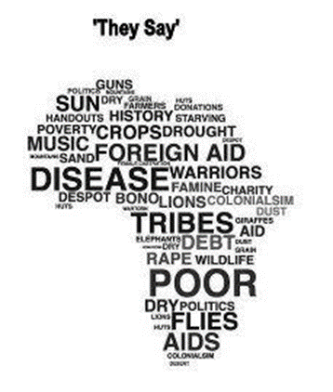

QUESTION FOUR: TEXTUAL EDITING 20 MARKS

Read the following extract adapted from the Sunday Times Travel Weekly Supplement 28 June 2015 and answer the questions which follow.
Big, scary yellow taxi
- Dawn in Greenwich Village on a Sunday morning is the perfect time to admire the brownstones and traffic-less, tree-lined streets – unless you have a plane to catch. My joy on the fleetingly quiet New York streets soon disappeared when I realised that the ubiquitous yellow cab was nowhere to be seen. A taxi finally screeched to a halt at my feet.
- My first impression was that it was returning from a night of stock-car racing – the evidence suggested the cabbie hadn’t been great at avoiding the other race entrants. Never mind; I was only wanting a ride to JFK, not to buy the car.
- Our departure was a sluggish affair accompanied by a strange sound that even General Motors would have found odd. I did not, however, need anyone to explain to me why the car was careering all over the road and why I appeared to be sitting head-and-shoulders higher than the driver. The shock absorbers were shot. As we picked up speed, I clung on for life.
- When I questioned the likelyhood that we’d ever reach the airport, the driver – greasy black hair and slim moustauche – looked back with an evil grin and an even greater fear set in.
- He smiled toothily and said, “I getta you dhere.”
- At the toll on the Brooklyn Bridge, the car stalled. Attempts to get it going were fruitless, cars hooted behind us and the toll clerk and the driver had a colourful conversation. Just as I was contemplating seeking alternative transport, the car roared to life in a cloud of smoke and we lurched off.
- Suddenly the last straw played its hand. We were 100m from the kerb-side check-in when the front suspension finally succumbed to past injuries and the car nose-dived into the tarmac. A spray of sparks 6m high were accompanied by the raucous agony of fast-moving metal tearing across the tarmac. Wide-eyed check-in agents dived for cover and passengers scooped up their children and fled. This was the nearest thing to a scene from Dante’s Inferno*.
- I, on the other hand, was the closest thing to Munch’s Scream**, with no sound uttered. The cab slammed into the kerb, seemingly in slow motion. The broken vehicle groaned in a cloud of steam as a crowd collected in awe and shock. The driver turned round one last time with an impish grin and said, “See? I gotta you here.”
*Munch’s Sream: This is a painting by Edvard Munch
** Inferno is an epic poem (1317) telling of Dante’s journey through hell.

4.1 Refer to paragraph 1
4.1.1 How does the meaning of traffic change with the addition of the suffix –less? (1)
4.1.2 The word ubiquitous has the following dictionary definition:
ubiquitous: having or seeming to have the ability to be everywhere at once
As what part of speech is ubiquitous functioning in the text? (1)
4.1.3 Give a one-word synonym for ubiquitous. (1)

4.2 Refer to: … the evidence suggested the cabbie hadn’t been great at avoiding the other race entrants (paragraph 2)
Why might this be an example of understatement? (2)

4.3 Rewrite the following sentence into Standard English:
The shock absorbers were shot. (paragraph 3) (1)

4.4 Correct the two spelling errors which appear in paragraph 4. (2)

4.5 Identify and discuss the use of the euphemism in paragraph 6. (2)

4.6 How does the visual image below reflect the events recorded in the passage? Substantiate your answer with reference to the text. (3)

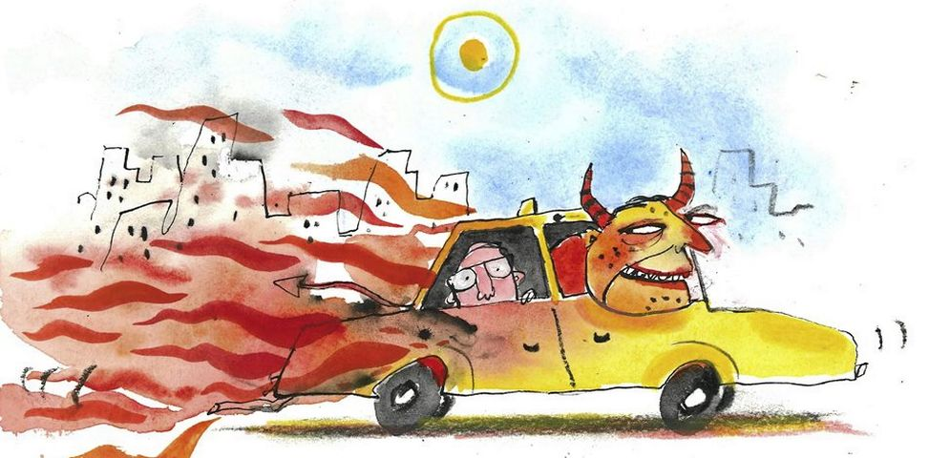
4.7 What is meant by the idiomatic expression the last straw (paragraph 7)? (2)

4.8 Identify and correct the error of concord in paragraph 7. Provide a reason for the correction you make. (2)

4.9 Refer to the visual of The Scream by Edvard Munch.
Why do you think the writer describes himself as the closest thing to Munch’s Scream (paragraph 8)? Quote from the passage and refer to the visual clues in the painting to substantiate your answer. (3)

The Scream (1893) by Edvard Munch (Source: http://www.edvardmunch.org/)

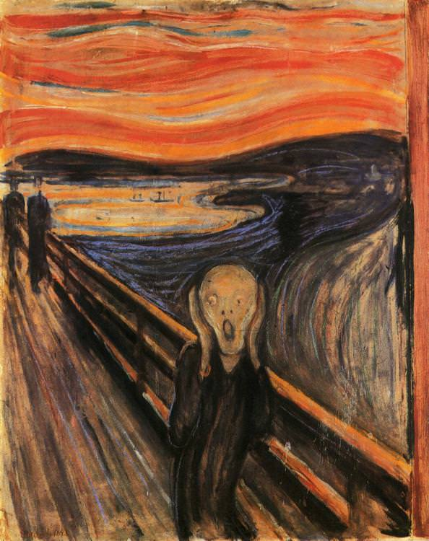

QUESTION FIVE: VISUAL LITERACY 10 MARKS

Refer to the cartoon below and answer the questions which follow.

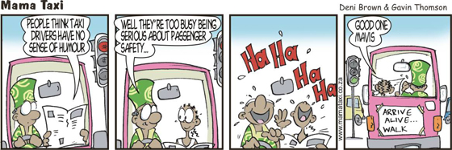

5.1 Identify and suggest a reason for the tone in which Mavis makes her statement in FRAME 2. (2)

5.2 Account for the reaction of Mavis and Zandi in FRAME 3. (2)

5.3 Explain why Zandi says Good one Mavis in FRAME 4, referring to the verbal and visual details in the frame. (2)

Examine the following cartoon

[Source: http://www.railforthevalley.com]

5.4 Discuss the irony in this cartoon. (2)
5.5 How does the visual layout of the cartoon support the message of the cartoonist? (2)

Text 1

That’ll do, pig.

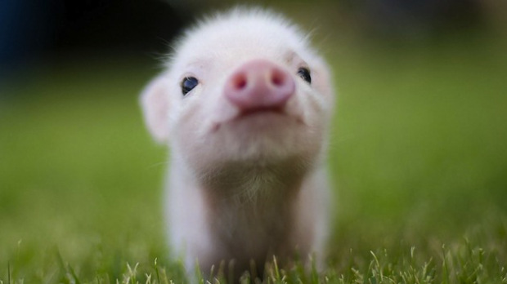

“Do you want to hear something truly perverse?” asked the chef.
1 I did. Jonny is a mercurial gastronome who delights in language almost as much as he relishes food, and I knew that when he said “perverse” he really meant it.
2 In France, he said, there is a certain songbird: the ortolan. It is the size of your hand and rather plain, but for connoisseurs of the dark culinary arts, it is the ultimate test of a chef’s skill – and morality.
3 Well, at least it was until fairly recently. The French government has banned the killing and cooking of ortolans, partly because they are so rare and partly because (here the storyteller laughed at the awfulness of what he was about to reveal) it’s just so completely depraved.
4 Ortolans are too small and delicate to be shot, he explained, and so instead they are trapped and put inside a box. A box full of grain. Into which no light whatsoever can penetrate. And so the frightened bird begins to eat. It eats and eats, growing fat on the grain that is its only comfort in a hellish universe.
5 At last the bird is taken out of its endless midnight and promptly drowned in a vat of Armagnac, a type of brandy. Its lungs fill with the liquor; a self-marinating delicacy.
6 The bird is cooked whole, bones and all, and the diners assemble. But instead of sharing their experience, they drape a large napkin over their heads and eat in the solitude of this small linen tent. Some say that the napkin traps the aromas, bathing the diners’ faces in a steamy mist of tortured songbird. Others say it allows them to spit out the bones without looking disgusting. But apparently the napkin’s most important purpose is to hide them from the disappointed gaze of God.
7 Jonny was laughing uproariously at the macabre spectacle of a tableful of French Ku Klux Klan lookalikes hiding from the Almighty as they wolfed down the evidence of a terrible crime. For me, it was a curiously human scene, like children driven by some barbaric curiosity into killing a frog, now hiding from their mother.
8 It reminded me of the tensions that lurk in our relationship with animals, especially the animals we eat. I had heard of culinary traditions that verge on psychopathy, but I had never before seen so clearly that child-like intersection of cruelty and shame.
9 I suspect we’ve been living with that intersection since the first human bludgeoned a passing rat. As we got better at hunting, we got better at denial, too, kidding ourselves that if we thanked a buck before we cut its throat and had a little spiritual moment, everything was in balance. It was the Stone Age equivalent of #Blessed: if you’re grateful for it, it doesn’t matter how you got it.
10 If all of this is sounding a little combative, I apologise. The fact is I’ve given up bacon and I want to blame someone. But please don’t think I’m trying to take any moral high ground. You should keep eating what you like. I’m still going to eat every cow, sheep or chicken that crosses my path. That’s because I’m a human and therefore a hypocrite when it comes to food. (Yes, vegans, you too: you might be saving the big fur; but your sprout farms are Armageddon for entire civilizations of creepy-crawlies.) All I’ve done is add pigs to the group of animals I’ve decided are lovable rather than edible. It’s not an ethical decision; it’s a sentimental one.
11 Then again, perhaps there is hope for us meat eaters. Even as I watch Babe, gently moaning and pawing the screen, scientists are hard at work making lab-grown flesh. Apparently the burger they conjured in a petri dish in 2013 tasted a bit like meat, though somewhat dry. So they’re already way ahead of McDonald’s.
12 It’s inevitable that this kind of meat will become more common. The planet can’t cope with the meat eaters it has, and by all accounts, petri flesh requires vastly less energy and water to produce. Soon I might be able to enjoy a rasher of facon while romping with my pet piglet, all the terrible contradictions removed by science.
13 But I wonder: when Jonny’s protégé prepares faux meat, will diners ask for it to look bloody? Will we always require evidence of a kill to really believe that it’s meat?

By Tom Eaton
Eaton, T. (2015). That'll do, pig.. Calling Through The Fog. Retrieved 8 November 2015, from https://callingthroughthefog.wordpress.com/2015/10/24/thatll-do-pig/

Text 2

Barack Obama threatens South Africa over chicken row
US President Barack Obama has given South Africa 60 days to remove barriers to US farm produce or face sanctions in a long-running row over chicken exports. South Africa banned US poultry imports last December after an outbreak of bird flu.
The latest escalation would threaten South African exports to the US of oranges, nuts and wine. South Africa exports $250m (£165m) of farm products to the US each year.
In a letter to Congress, Mr Obama said he was taking the step because South Africa "continued to impose barriers to US trade".
In contrast, Africa's second-largest economy has been able to export its meat to the United States duty-free.
The Unites States also says South Africa has used unwarranted sanitary restrictions to keep out US pork and beef.
South Africa says it is taking the warning seriously and is working to find a solution. Trade Minister Rob Davies told reporters in Cape Town that they are "pretty close to resolving the sanitary matters that were outstanding".
The BBC's Lerato Mbele in Johannesburg says high-value goods such as cars remain unaffected by the latest dispute.
Eliminating barriers to US trade and investment is one of the criteria for membership of the African Growth and Opportunity Act (Agoa), which was renewed earlier this year and provides duty-free access to goods from sub-Saharan African countries, ranging from crude oil to clothing.
But if the Americans are trying to force the South Africans to accept their poultry exports, they may be going about it the wrong way. The South African government is adamant that the delay lies not with them, but with the independent vets looking into whether or not the imported US birds are safe.
Nonetheless, missing the 15 October deadline to agree new animal health rules infuriated the Americans.
The South Africans know this and are in no mood to jeopardise the billions tied up in their car industry which gains significant advantage from exporting tariff-free into the US. The investment figures in South Africa's automotive sector are not chicken feed and are unlikely to be risked in a trade spat.

